|  |  |
| --- | --- |
| **South East England**  **General Histopathology EQA Scheme**  **Round y**  **Preliminary Case Analyses**  Cases **927** to **938**  Circulated **May - June 2026**  *** responses (**%) |  |

Prepared: **July 2024** Authorised by: Dr. Nipin Bagla Date: 15/07/24

**Please return to** mtw-tr.EQA@nhs.net **by Friday 26th July Detailed Instructions for completion can be found on page 13 of this document**

___________________________________________________________________________

**Case Number: 927**

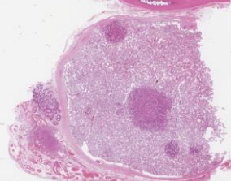

**Diagnostic category: GU**

**Clinical** : M35. Testicular pain? cancer

**Specimen** : Testis

**Macro** : Cut surface shows multiple small yellowish nodules

|  |  |
| --- | --- |
| * **Please merge any of the following that you consider to be synonym diagnoses, or so closely linked together as to make no clinically significant difference.** * **You may suggest as many different merging combinations as necessary e.g. merge 1 & 2 and merge 3 & 4 etc.** * **All unmerged diagnoses should be considered discrete diagnoses, different from any other.** | |
| **1** | **Leydig Cell Hyperplasia** |
| **2** | **Leydig Cell Hyperplasia with Sertoli Cell only syndrome** |
| **3** | **Leydig cell tumour** |
| **4** | **Testis - Leydig cell tumour. Hilum - angioleiomyoma** |
| **5** | **Granulosa cell tumour** |
| **6** | **Interstitial cell hyperplasia** |
|  |  |

CASE CONSULTATION:

**Please suggest diagnoses to merge (numbers only)**

|  |
| --- |
|  |
| **Comments** |

**Case Number: 928**

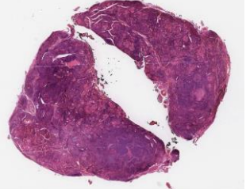

**Diagnostic category: Endocrine**

**Clinical :** F45. Patient with known Hashimoto's thyroiditis. Total   
 thyroidectomy.

**Specimen :** Thyroid  **Macro :** Enlarged thyroid with white nodules in left and right lobes.

|  |  |
| --- | --- |
| * **Please merge any of the following that you consider to be synonym diagnoses, or so closely linked together as to make no clinically significant difference.** * **You may suggest as many different merging combinations as necessary e.g. merge 1 & 2 and merge 3 & 4 etc.** * **All unmerged diagnoses should be considered discrete diagnoses, different from any other.** | |
| **1** | **Papillary carcinoma with Hashimotos thyroiditis** |
| **2** | **Papillary carcinoma** |
| **3** | **Papillary microcarcinoma** |
| **4** | **Lymphocytic Thyroiditis / Hashimotos** |
| **5** | **Hyalinising trabecular tumour of thyroid** |
|  |  |
|  |  |
|  |  |
|  |  |
|  |  |

CASE CONSULTATION:

**Please suggest diagnoses to merge (numbers only)**

|  |
| --- |
|  |
| **Comments** |

**Case Number: 929**

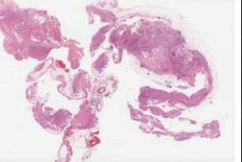

**Diagnostic category: Respiratory**

**Clinical :** M73. Pleural biopsy (left). Left sided pleural effusion. PMHx:   
 HRN, BPH, Hypercholestosis. Penicillin allergy. Procedure:   
 Left VATS drainage and pleural biopsy +TALC   
 pleurodeses.? Malignancy   
 **Specimen :** Pleural Biopsy

**Macro :** Firm pieces of fibrofatty tissue 60mm in aggregate. Sliced   
 and all taken in 6 blocks.

**Immuno :** CK7 - 3+, TTF1 - 3+, MOC31 - 3+, BEREP4 - 3+

|  |  |
| --- | --- |
| * **Please merge any of the following that you consider to be synonym diagnoses, or so closely linked together as to make no clinically significant difference.** * **You may suggest as many different merging combinations as necessary e.g. merge 1 & 2 and merge 3 & 4 etc.** * **All unmerged diagnoses should be considered discrete diagnoses, different from any other.** | |
| **1** | **Adenocarcinoma of lung** |
| **2** | **Adenocarcinoma of ? papillary thyroid origin** |
| **3** | **Papillary Adenocarcinoma of ? urothelial origin** |
| **4** | **Primary Adenocarcinoma** |
| **5** | **Papillary carcinoma - thyroid or lung** |
| **6** | **Adenocarcinoma** |
| **7** | **Metastatic adenocarcinoma** |
|  |  |
|  |  |
|  |  |

CASE CONSULTATION:

**Please suggest diagnoses to merge (numbers only)**

|  |
| --- |
|  |
| **Comments** |

**Case Number: 930**

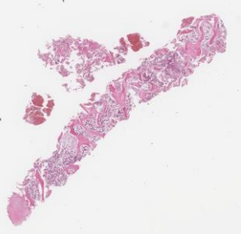

**Diagnostic category: Lymphoreticular**

**Clinical** : M38. sm/up on oral pred previous arrest following bee sting.

No adrenaline widespread skin lesions, difficult to control.

**Specimen** : BMT

**Macro** : Single bony core measuring 18mm in length, 3mm in diameter. Blood clot included. All taken for decal.

**Immuno** : CD34/CD117 - no increased blasts.

|  |  |
| --- | --- |
| * **Please merge any of the following that you consider to be synonym diagnoses, or so closely linked together as to make no clinically significant difference.** * **You may suggest as many different merging combinations as necessary e.g. merge 1 & 2 and merge 3 & 4 etc.** * **All unmerged diagnoses should be considered discrete diagnoses, different from any other.** | |
| **1** | **Mastocytosis** |
| **2** | **Malakoplakia** |
| **3** | **Refer to Haempath / Abnormal / reactive** |
| **4** | **Idiopathic hypereosinophilic syndrome / eosinophilia** |
| **5** | **Chronic eosinophilic leukaemia / CML** |
| **6** | **Lymphoproliferative disease / Granulocyte hyperplasia** |
| **7** | **LCH / Rosai-Dorfman disease** |
| **8** | **Fibrosis/myleoproliferative/myleodysplastic/ morphologically abnormal** |
| **9** | **Metastatic GIST** |
| **10** | **Allergy / hypersensitivity / fungal** |

CASE CONSULTATION:

**Please suggest diagnoses to merge (numbers only)**

|  |
| --- |
|  |
| **Comments** |

**Case Number: 931**

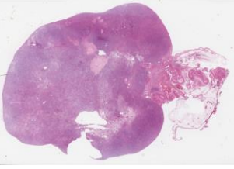

**Diagnostic category: Gynae**

**Clinical :** F65. Post-menopausal bleeding. ?sarcoma. At laparotomy, ?bilateral fibromas. Hysterectomy and BSO

**Specimen :** Ovary

**Macro :** Bilateral enlarged ovaries, right ovary 80 x 60 x 45mm and left ovary 35 x 30 x 10mm. Cut section of both solid, white and lobulated.

**Immuno :** Lesional cells positive to BEREP4, Cam 5.2, E-cadherin, CK7,

CK20, CDX2 and CEA.

Negative to ER, PR, WT-1, TTF-1, Inhibin, Calretinin, Desmin&

SMA. The patient on further investigation had linitis plastcia   
 (biopsy proven - adenocarcinoma with signet ring cell

differentiation of stomach)

|  |  |
| --- | --- |
| * **Please merge any of the following that you consider to be synonym diagnoses, or so closely linked together as to make no clinically significant difference.** * **You may suggest as many different merging combinations as necessary e.g. merge 1 & 2 and merge 3 & 4 etc.** * **All unmerged diagnoses should be considered discrete diagnoses, different from any other.** | |
| **1** | **Metastatic Gastric adenocarcinoma (Krukenburg tumour)** |
| **2** | **Metastatic adenocarcinoma with signet cells & sarcomatoid component** |
| **3** | **Metastatic appendiceal signet ring cell adenocarcinoma** |
| **4** | **Metastatic adenocarcinoma** |
|  |  |
|  |  |
|  |  |
|  |  |

CASE CONSULTATION:

**Please suggest diagnoses to merge (numbers only)**

|  |
| --- |
|  |
| **Comments** |

**Case Number: 932**

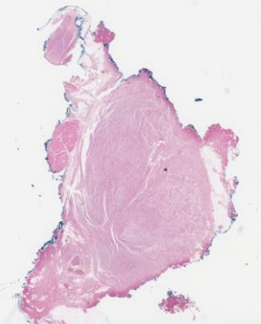

**Diagnostic category: GI**

**Clinical** : M43. Mass right parotid region. History of pleomorphic   
 adenoma.

**Specimen** : Soft Tissue

**Macro** : Fibrofatty tissue 28 x 25 x 10mm. Slicing reveals a well circumscribed pale area 18 x 12 x 8mm**.** :

|  |  |
| --- | --- |
| * **Please merge any of the following that you consider to be synonym diagnoses, or so closely linked together as to make no clinically significant difference.** * **You may suggest as many different merging combinations as necessary e.g. merge 1 & 2 and merge 3 & 4 etc.** * **All unmerged diagnoses should be considered discrete diagnoses, different from any other.** | |
| **1** | **(Traumatic) Neuroma** |
| **2** | **Neurofibroma** |
| **3** | **Neurothekeoma** |
| **4** | **Schwannoma** |
| **5** | **Benign neural tumour** |
|  |  |
|  |  |
|  |  |
|  |  |
|  |  |

CASE CONSULTATION:

**Please suggest diagnoses to merge (numbers only)**

|  |
| --- |
|  |
| **Comments** |

**Case Number: 933**

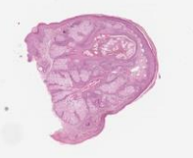

**Diagnostic category: Skin**

**Clinical** : 45M. Skin tag right side of nose

**Specimen** : Skin

**Macro** : None provided

|  |  |
| --- | --- |
| * **Please merge any of the following that you consider to be synonym diagnoses, or so closely linked together as to make no clinically significant difference.** * **You may suggest as many different merging combinations as necessary e.g. merge 1 & 2 and merge 3 & 4 etc.** * **All unmerged diagnoses should be considered discrete diagnoses, different from any other.** | |
| **1** | **Sebaceous Hyperplasia** |
| **2** | **Sebaceous Adenoma** |
| **3** | **Sebaceoma** |
| **4** | **Rhinosporidiosis** |
| **5** | **Fibrofolliculoma** |
| **6** | **Sebaceous naevus** |
|  |  |
|  |  |
|  |  |
|  |  |

CASE CONSULTATION:

**Please suggest diagnoses to merge (numbers only)**

|  |
| --- |
|  |
| **Comments** |

**Case Number: 934**

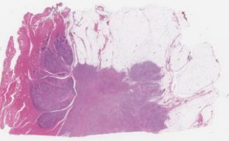

**Diagnostic category: Breast**

**Clinical** : F50. Right Breast. P3, M4, U5 lesion

**Specimen** : Breast

**Macro** : 32g. 65x40x25mm. Firm white mass. 30mm

**Immuno** : ER positive. HER-2 negative. E-cadherin, incomplete   
 membranous reactivity.

|  |  |
| --- | --- |
| * **Please merge any of the following that you consider to be synonym diagnoses, or so closely linked together as to make no clinically significant difference.** * **You may suggest as many different merging combinations as necessary e.g. merge 1 & 2 and merge 3 & 4 etc.** * **All unmerged diagnoses should be considered discrete diagnoses, different from any other.** | |
| **1** | **Invasive carcinoma NST** |
| **2** | **Tubulo-lobular carcinoma** |
| **3** | **Mixed ductal and (pleomorphic) lobular carcinoma** |
| **4** | **Invasive lobular carcinoma** |
| **5** | **Invasive tubular carcinoma** |
|  |  |
|  |  |
|  |  |
|  |  |
|  |  |

CASE CONSULTATION:

**Please suggest diagnoses to merge (numbers only)**

|  |
| --- |
|  |
| **Comments** |

**Case Number: 935**

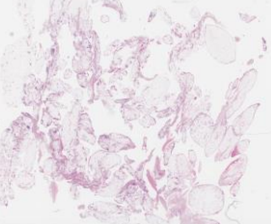

**Diagnostic category: Miscellaneous**

**Clinical** : M73. Biopsies of free tissue in knee joint.

**Specimen** : Tissue from knee

**Macro** : Multiple pieces of yellow / white soft tissue 30 x 20 x 6 mm.   
 All taken

|  |  |
| --- | --- |
| * **Please merge any of the following that you consider to be synonym diagnoses, or so closely linked together as to make no clinically significant difference.** * **You may suggest as many different merging combinations as necessary e.g. merge 1 & 2 and merge 3 & 4 etc.** * **All unmerged diagnoses should be considered discrete diagnoses, different from any other.** | |
| **1** | **Synovitis - lipomatosis not mentioned** |
| **2** | **Osteoarthritis** |
| **3** | **Synovial Lipomatosis / Lipoma arborescens** |
| **4** | **Papillary synovitis with prominent plasma cells; PVNS** |
| **5** | **Lipoma** |
| **6** | **Rheumatoid arthritis** |
| **7** | **Inflammation and fat necrosis** |
|  |  |
|  |  |
|  |  |

CASE CONSULTATION:

**Please suggest diagnoses to merge (numbers only)**

|  |
| --- |
|  |
| **Comments** |

**Case Number: 936**

**Diagnostic category: Digital Only - Misc**

**Clinical** : M79. Progressive paraparesis, dural based tumour at T11

**Specimen** : Spinal Tumour

**Macro** : Gritty tissue fragments



**DIGITAL ONLY**

*[Response required unless exempt]*

|  |  |
| --- | --- |
| * **Please merge any of the following that you consider to be synonym diagnoses, or so closely linked together as to make no clinically significant difference.** * **You may suggest as many different merging combinations as necessary e.g. merge 1 & 2 and merge 3 & 4 etc.** * **All unmerged diagnoses should be considered discrete diagnoses, different from any other.** | |
| **1** | **Meningioma** |
| **2** | **Diffuse spinal dural calcification** |
|  |  |
|  |  |
|  |  |
|  |  |
|  |  |
|  |  |
|  |  |
|  |  |

CASE CONSULTATION:

**Please suggest diagnoses to merge (numbers only)**

|  |
| --- |
|  |
| **Comments** |

**EDUCATIONAL CASE**

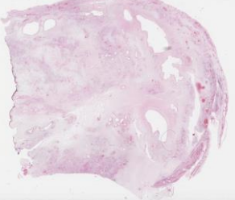

**Case Number: 937**

**Clinical** : M70. Para-urethral cyst at the base of the penis

**Specimen** : Soft Tissue from penis

**Macro** : Single piece of un-oriented partly membrane covered soft tissue 90x65x20mm with attached fibrous tissue 45x20x5mm. External surface cystic structures filled with fluid, 10mm in largest dimension. Soft spongy grey/white filled serous / mucoid material.

**Immuno** : CD34: Diffusely positive. ER: Scattered cells expressing positive   
 staining MNF116 / S100 / STAT6: Negative. Case was referred   
 for specialist opinion.

**Suggested diagnoses:**

|  |  |
| --- | --- |
| Angiomyxoma x 73  Cellular Angiofibroma x 44  solitary fibrous tumour x 12  Angiomyofibroblastoma  x 5  Myofibroblastoma mammary type x 3  Soft tissue myxoma x 3  Neurofibroma x 2  Fibromyxoma.  Superfical fibromatoid tumour with myxoid stroma  Spindle cell lipoma  Pseudomyofibroblastic tumour  SUPERFICIAL CD34 POSITIVE MYOFIBROBLASTIC TUMOUR  Hamartomatous change  Lymphangioma  myointimoma  Aggressive angiolipoma  Angiomyxoid Fibroma of penis  Mesenchymal tumour  Mucoid cyst  FIBROMIXOID TUMOUR  Aggressive Angiomyoma  Low grade chronic inflammation, haemosiderin and oedema ? reactive/ischaemic process  Benign para-urethral Degenerative cyst | Neuroma  Fibroblastic tumour  Myxoma x 2  PEComa  Neurofibroma with myxoid change  Heamangioma  Vascular lesion, refer for expert opinion  Haemangioendothelioma  Nodular fasciitis x 2 Superficial myofibroblastoma  Arterio-venous malformation  DDs : IMT, pleomorphic hyalinizing angiectatic tumour, deep fibrous histiocytoma ,liposarcoma  VENOUS HEMANGIOMA  Low-grade, vascular, fibromyxoid spindle cell proliferation.  Myxoid fibroma  Low gade myxofibrosarcoma  Epithelioid haemangioma  Arteriovenous malformation  sammomatous meningioma |

**Reported Diagnosis: Cellular AngiofibromaEDUCATIONAL CASE**

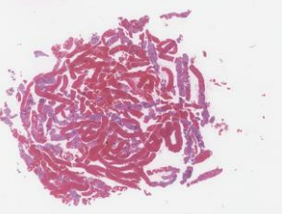

**Case Number: 938**

**Clinical** : F29. Althralgia, erythema nodosum and large mediastinal   
 lymphadenopathy.

**Specimen** : EBUS – Station 7

**Macro** : Multiple pieces of haemorrhagic and cream cores in aggregate,   
 20 x 20mm.

**Immuno** : Stains for micro-organisms negative

**Suggested diagnoses:**

|  |  |
| --- | --- |
| Sarcoidosis x 145  Granulomatous inflammation x 8   Granulomatous lymphadenitis x 10  Granulomata? Related to erythema nodosum  ? intermixed interdigitating dendritic reticulum cells |  |

**Reported Diagnosis: Sarcoidosis**

**EQA Preliminary Case Consultation Instructions**

1. Please review the preliminary results and decide whether or not any diagnoses should be merged. Merging should be considered if

* Two or more diagnoses are synonyms
* The difference between two diagnosis would not alter clinical management of the patient

Note:

* More than one combination of merges may be appropriate e.g. merging two or more malignant diagnoses together and merging two or more benign diagnoses together.
* After merging, the remaining list of diagnoses should be clinically distinct and you consider only one to be the “correct” diagnosis

1. Please only use the number of the diagnosis, not its full description. If you do not think any merging should be performed, then please indicate this (“merge none”)
2. The comments field can be used for your comments on the suitability of the case or any other comments you may have.
3. Please ensure you comment on every case.
4. Please complete the attached sheets and return to the EQA Office by the deadline date above. Any incomplete or late returns will not be accepted.
5. Please ensure your confidential code is entered on your form.

General notes about the consultation process

Those taking part in the Case Consultation for a round are considered the expert participant group and each expert participant will be awarded an extra CPD point per round.

Please note the purpose of consultation is not to vote for the “correct” answer. This has already been determined by the percentage agreement of submitted diagnoses and the confidence level of the diagnosis. It is perfectly possible that there may be 80% agreement to merge two benign diagnoses, but the “correct” diagnosis may be a malignant diagnosis.